ITA0305- Mobile Computing
LAB EXPERIMENT
Name: G.Ganesh
Reg NO:192373008

14. Develop a flowchart in Figma explaining the operation of General Packet Radio
Service (GPRS).

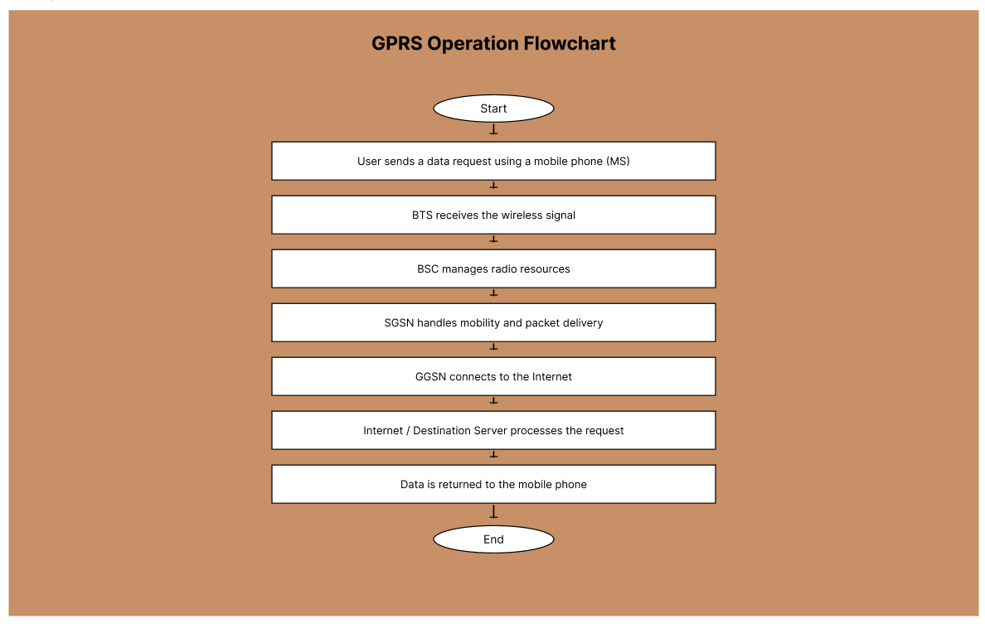
https://www.figma.com/design/qBzLvMjEW2W81LNGOZuJsb/program14?node-id=0-1&p=f&t=NiNIlIMBNa9T3nZt-0

